
Ml project
Adult Income

January 10, 2026
Abdalrhman jehad
HAZEM Alalfi
ZAID Khrisat

1.Introduction
This project focuses on building and evaluating a machine learning system to predict income levels using the Adult Census Income dataset. The task is formulated as a supervised classification problem, where the goal is to determine whether an individual earns more than 50K per year based on demographic and employment-related features.
The project involves applying multiple machine learning algorithms and comparing their performance to identify the most effective model for this problem.

2. Data Description
This dataset contains 48,842 rows and 14 features, describing demographic and economic information, with a target variable indicating whether income is above or below 50,000 dollars.

2.1 Dataset Source
Adult dataset

2.2 Variables Table
Feature Name | Type | Description
Age | Integer | Age in years
Workclass | Categorical | Private, Self-emp-not-inc, Self-emp-inc, Federal-gov, Local-gov, State-gov, Without-pay, Never-worked.
fnlwgt | Integer | Census sampling weight
education | Categorical | High education level
Education_num | Integer | Number of years of education
Martial_status | Categorical | Married-civ-spouse, Divorced, Never-married, Separated, Widowed, Married-spouse-absent, Married-AF-spouse.
Occupation | Categorical | Job occupation
relationship | Categorical | Wife, Own-child, Husband, Not-in-family, Other-relative, Unmarried.
race | Categorical | White, Asian-Pac-Islander, Amer-Indian-Eskimo, Other, Black.
Sex | Binary | Female, Male.
Capital_gain | Integer | Capital gains reported
Capital loss | Integer | Capital losses reported
Hours-per-week | Integer | Hours worked per week
Native_country | Categorical | Country of origin
Income | Binary traget | <=50K or >50K annually

3. Data Preprocessing

3.1 Missing Value
Missing values represented by '?' were replaced with NaN and removed to ensure clean analysis.
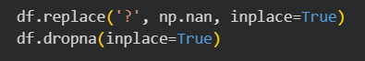

Figure 1: handle missing values

3.2 Duplicate
Duplicates are removed
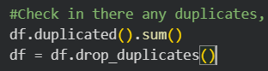

Figure 2: handle duplicated value

3.3 Outliers
We did not remove outliers for several reasons. First, many “extreme values” are actually real and meaningful, and removing them would cause the loss of important information. Second, linear models can handle such values after proper scaling, and models like SVM and logistic regression are less affected when the data is scaled correctly.

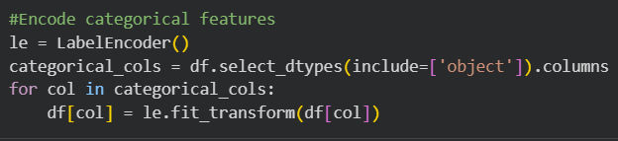
3.4 Encode Categorical Features
Figure 3: encode categorical features

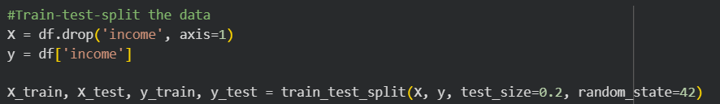
3.5 Splitting data into training and testing sets
Figure 4: train/test split

3.6 Scaling features
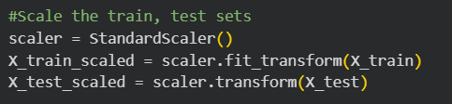

Figure 5: scaling features

3.7 Handle the data imbalance Using SMOTE
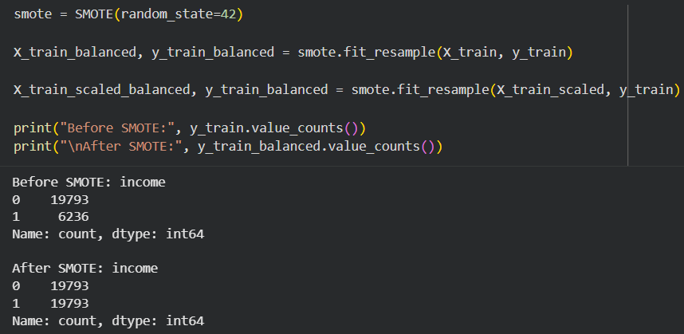

Figure 6: handel the data imbalance

4. Exploratory Data Analysis
Exploratory Data Analysis (EDA) was done to examine the main features, check their distributions, and find relationships between the variables and the target.

4.1 Histogram
The histogram shows the distribution of age in the dataset, with different colors representing the two income groups. It helps visualize how age varies between people earning more than 50K and those earning 50K or less.
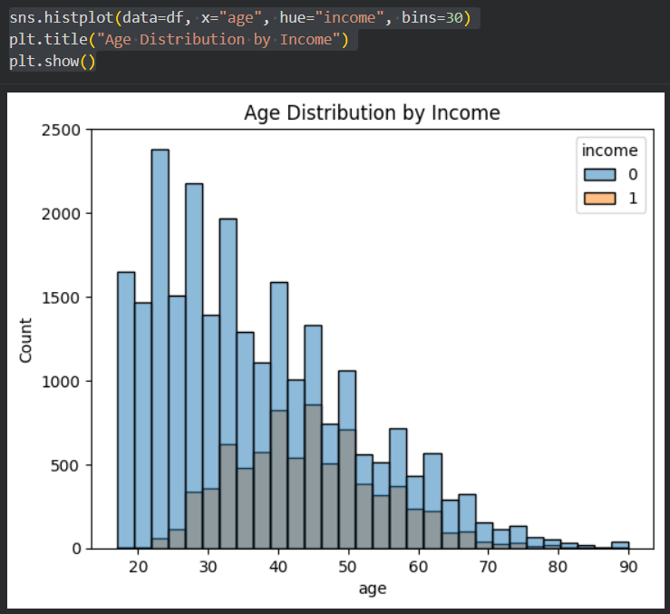

Figure 7: Age distribution by Income

4.2 Scatter plot
The scatter plot shows the relationship between capital gain and hours worked per week, with points colored by income group. It helps to visualize how earning patterns vary with work hours and capital gains.
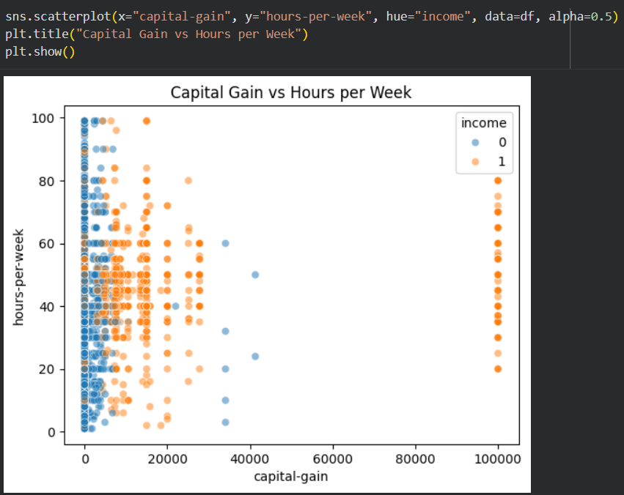

Figure 8: Capital Gain VS Hours per Week

4.3 Count plot
The count plot shows the number of males and females in each income group. It helps to compare the distribution of income across genders.
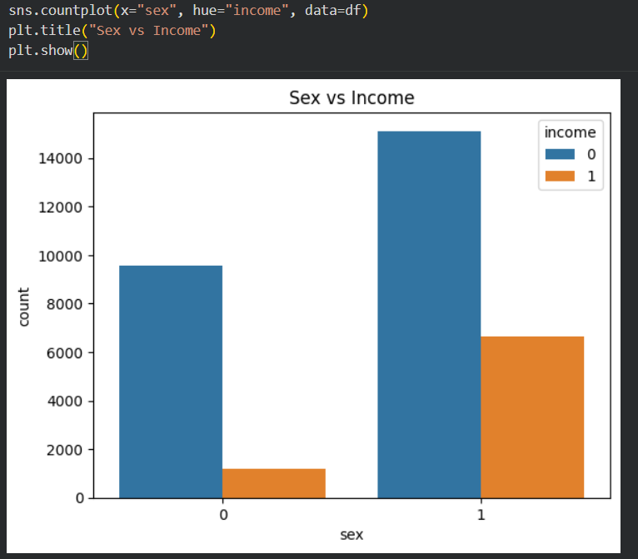

Figure 9: Sex VS Income

4.4 Count Plot
The count plot shows how different education levels are distributed across income groups. It helps to understand the relationship between education and earning more than 50K.
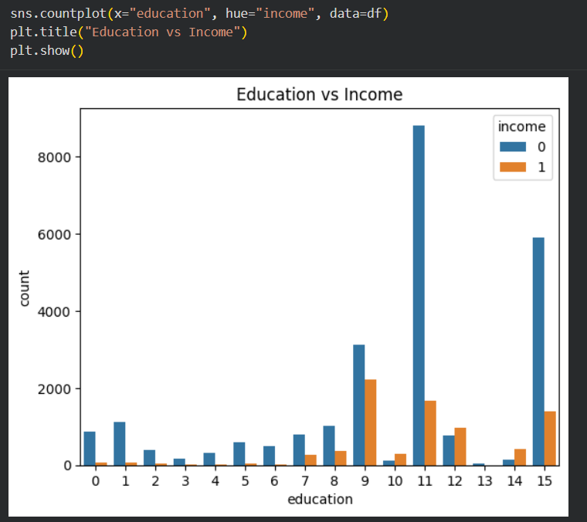
Figure 10: Eduction VS Income

4.5 Correlation Between Numeric Features
The heatmap shows the correlation between numeric features in the dataset. It helps to understand how features like age, hours per week, and capital gain/loss are related to each other.
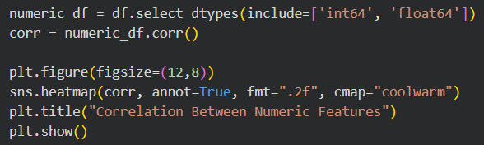

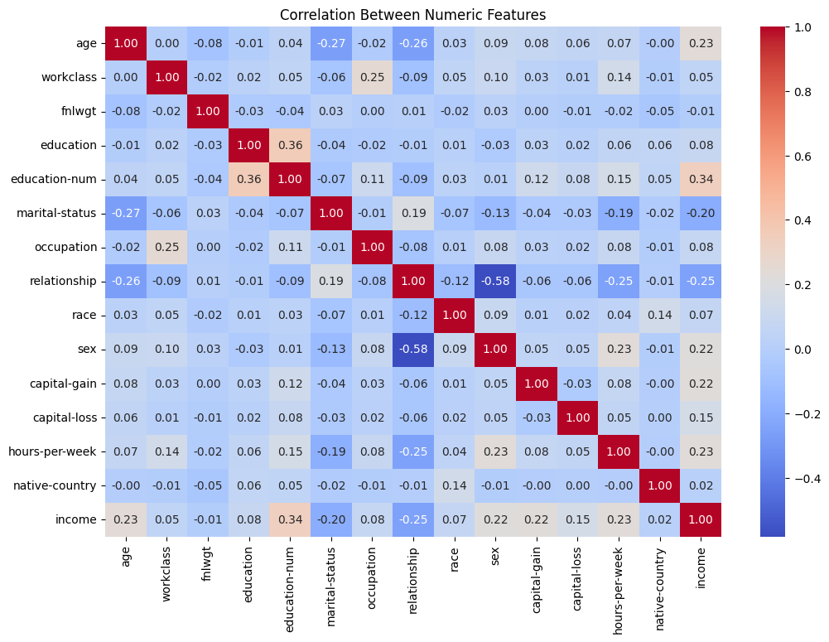
Figure 11: Correaltion Between Numeric Features

5.Model Performance Comparison
The objective of this stage is to evaluate and compare the performance of different machine learning classification algorithms on the Adult Census Income dataset in order to identify the most effective model for income prediction.
Models Used
The following supervised learning algorithms are applied and compared:
- Voting Classifier
- XGB Classifier
- Random Forest Classifier
- Support Vector Machine
- GaussianNB
- KNeighborsClassifier
- Logistic Regression

Model | Accuracy | Precision | Recall | F1_score
Voting Classifier | 85.56% | 0.69 | 0.75 | 0.72
XGB Classifier | 85.43% | 0.68 | 0.78 | 0.73
Random Forest Classifier | 84.65% | 0.68 | 0.71 | 0.69
Support Vector Machine | 79.59% | 0.55 | 0.87 | 0.68
Gaussian NB | 78.8% | 0.63 | 0.33 | 0.43
KNeighborsClassifier | 78.44% | 0.54 | 0.79 | 0.64
Logistic Regression | 76.75% | 0.52 | 0.79 | 0.63`

5.1 Random Forest + XGBoost Voting Classifier
Voting Classifier is an ensemble model that combines Random Forest and XGBoost to improve prediction performance. On this dataset, it achieved an accuracy of about 85.56%, with precision 0.69, recall 0.75, and F1-score 0.72, indicating that it correctly identifies most positive cases while maintaining a high overall accuracy. These results show that combining two strong classifiers captures much of the signal in the dataset and balances performance across classes.

5.2 XGBoost
XGBoost is a gradient boosting model that builds sequential trees to improve prediction. On this dataset, it achieved an accuracy of about 85.43%, with precision 0.68, recall 0.78, and F1-score 0.73, demonstrating good detection of positive cases while keeping the overall performance high. These results indicate that XGBoost effectively captures the relationships in the features and is robust for this classification task.

5.3 Random Forest Classifier
Random Forest is an ensemble model that builds multiple decision trees and combines their predictions to improve accuracy. On this dataset, it achieved an accuracy of about 84.65%, with precision 0.68, recall 0.71, and F1-score 0.69, showing that it correctly identifies most positive cases while maintaining good overall performance. These results indicate that Random Forest effectively captures patterns in the features and balances predictions across classes.

5.4 Support Vector Machine
Support Vector Machine (SVM) is a linear classifier that finds the optimal boundary between classes. On this dataset, it achieved an accuracy of about 79.59%, with precision 0.55, recall 0.87, and F1-score 0.68, indicating that it identifies most positive cases but makes more false positive predictions. These results show that SVM is effective in detecting the positive class but less precise overall.

5.5 Naïve Bayes
Naïve Bayes is a probabilistic classifier based on Bayes’ theorem. On this dataset, it achieved an accuracy of about 78.8%, with precision 0.63, recall 0.33, and F1-score 0.43, indicating that it struggles to detect positive cases despite good accuracy for the majority class. These results highlight that Naïve Bayes may be less suitable for imbalanced datasets in this scenario.

5.6 K-Nearest Neighbors (KNN)
K-Nearest Neighbors (KNN) predicts class labels based on the majority vote of nearby points. On this dataset, it achieved an accuracy of about 78.44%, with precision 0.54, recall 0.79, and F1-score 0.64, showing that it captures most positive cases but has limited precision. These results indicate that KNN can identify positives fairly well but struggles with false positives.

5.7 Logistic Regression
Logistic Regression is a linear model that estimates probabilities of class membership. On this dataset, it achieved an accuracy of about 76.75%, with precision 0.52, recall 0.79, and F1-score 0.63, demonstrating that it detects most positive cases but with moderate precision. These results show that a simple linear model captures some patterns but is less accurate compared to ensemble or tree-based methods.

5.8 Best Model
We have applied multiple Machine learning Algorithm to the Adult Census Income dataset to predict whether an individual earns more than 50K per year. The models were evaluated using accuracy, precision, recall, and F1-score
Among all models, the Voting Classifier achieved the best overall performance with an accuracy of 85.56% and a balanced F1-score for the high-income class. This indicates that combining multiple models helps improve generalization and stability.
The XGBoost Classifier showed competitive performance with an accuracy of 85.43% and the highest recall for the high-income class, making it effective at identifying individuals earning more than 50K. However, this comes with slightly lower precision.
The Random Forest Classifier also performed well, achieving an accuracy of 84.65%, demonstrating its ability to capture nonlinear relationships in the data.
In contrast, Support Vector Machine, KNN, and Logistic Regression showed lower overall accuracy. While some of these models achieved high recall, they suffered from lower precision, leading to more false positives. Gaussian Naive Bayes performed the weakest on the minority class due to its strong independence assumptions.
Overall, ensemble-based models outperformed individual classifiers, highlighting their effectiveness in handling complex, real-world datasets with class imbalance.

6. Conclusion
This project applied several machine learning classification algorithms to predict income levels using the Adult Census Income dataset. After performing data preprocessing, feature scaling, and handling class imbalance with SMOTE, multiple models were trained and evaluated using accuracy, precision, recall, and F1-score.
The results showed that ensemble-based models performed better than individual classifiers. The Voting Classifier achieved the highest accuracy of 85.56%, followed closely by XGBoost and Random Forest. These models demonstrated strong ability to capture complex patterns in the data and provided balanced performance across classes. Simpler models such as Logistic Regression, KNN, and Gaussian Naïve Bayes showed lower performance, particularly in predicting the high-income class.
Overall, the study confirms that ensemble learning methods are effective for income prediction tasks and emphasizes the importance of proper data preprocessing and model evaluation for achieving reliable results.

